FRANCE

Create table sid_france.

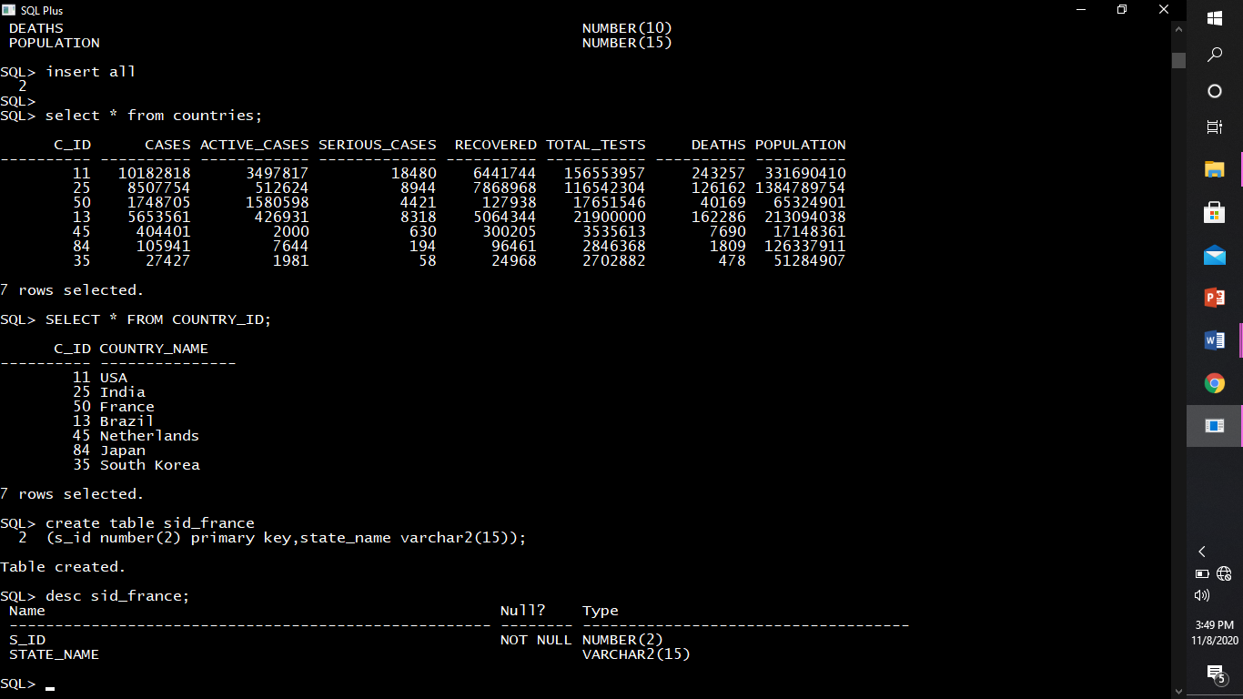

Describing structure of sid_france.



Inserting rows into sid_france.

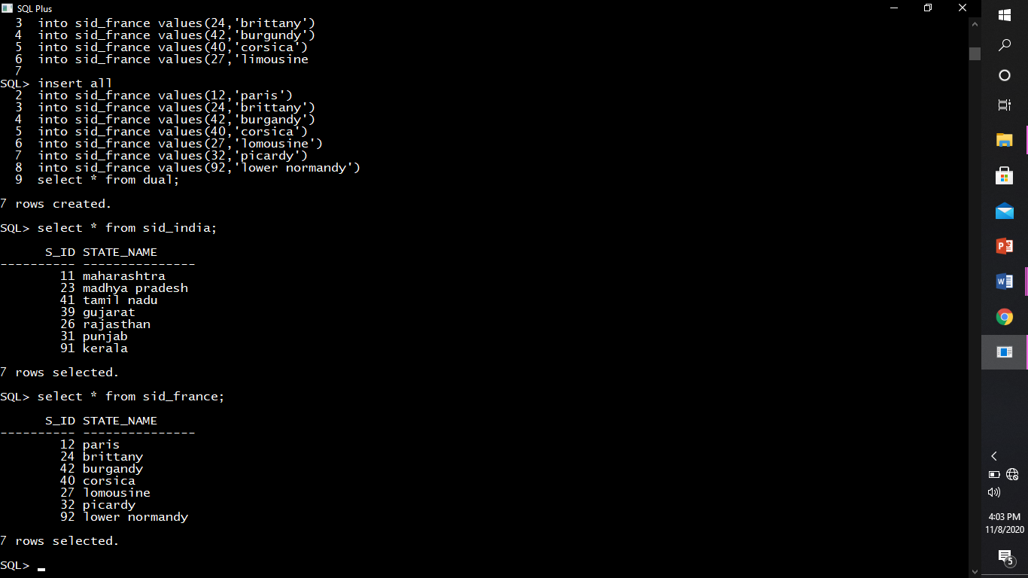



Create table france_states.

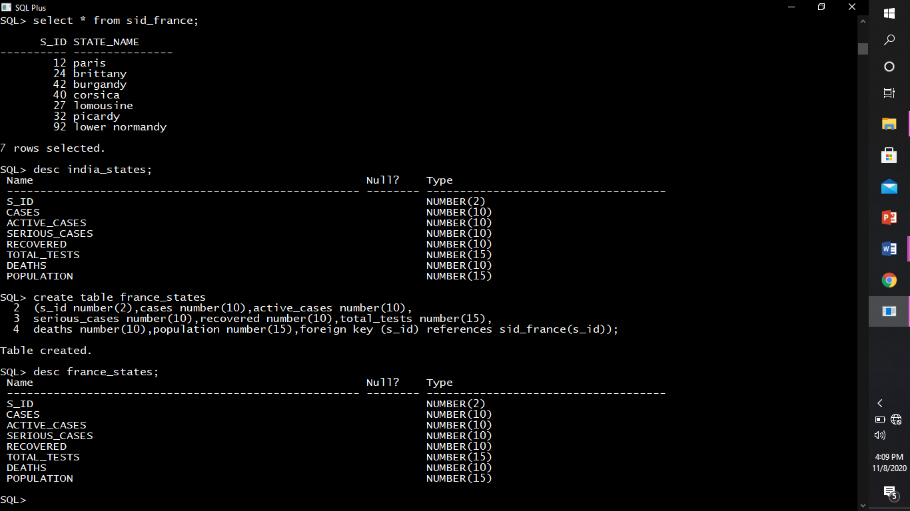

Describing structure of france_states.



Inserting rows into france_states.

